
https://atlas.cid.harvard.edu/

Optimal Industry Development Strategy Using Economic and Product Complexity

Singapore

─
The Economic Complexity Lab - Columbia University
Alexandra Garcia, Kelly Mi, Margarita Demkina, Allison Lin, Helena Yang, Jane Zhang, Daniel Xu, Ryo Shibata, Haoxian Chen, Davepriyan Gunaratnam, Rohan Macherla, Ajit Akole, Shomik Ghose, Alex Wei-Liang Ku, Sannidhya Modi, Xilin Wang

Optimal Industry Development Strategy for Singapore

0. Executive Summary

In this report, we aim to uncover the economic path Singapore went through during the period from 2013 to 2021. Specifically, we dive into the topic through a macroeconomic overview of Singapore from the perspective of Gross Domestic Product (GDP) and Economic Complexity Index (ECI), which reflect countries’ production capability and production structure, respectively. We find that during the period of our interest, Singapore demonstrated a low level of economic growth with an average annual GDP growth rate of 3.6% between 2013 and 2018 and 2.31% between 2019 and 2021, with a decreased economic complexity compared to other major developed and emerging economies.

The negative progress during the period, we believe, can be partially explained through the analysis of the economic and product complexity structure of Singapore on the industry group level, as well as the declining macro and microeconomic strategies. The product classification system we adopt allows us to measure the realized industry development for various industry groups and to observe that Singapore regressed in developing most of its industries during the period while its developed and emerging counterparts and economies around the globe also adopted complex and progressive paths with variable degrees of success.

Based on our analysis of the opportunity gain and sensitivity analysis of major industry groups, Singapore could further its gains by prioritizing Chemicals, Machinery and Construction in 2018. Three years later, in 2021, its focus should shift to the Energy Drilling and Mining and Precious Stones industries, which are also one of the more developed industries at the time. We further note that Singapore has a slightly mismatched development strategy that indicates a moderate level (compared to other developed and emerging countries) of structural optimality on the complexity level, having an adjusted R-square of around -5.1% in 2018 and a much higher score of 39.1% in 2021, demonstrating shift and improvement in development. Since a significant positive correlation exists between five-year GDP growth between 2013 and 2018 and the structural optimality index of an economy as we define and calculate, Singapore indeed has a suboptimal growth experience as compared with fast-growing economies both on a regional scale and on a global scale and has the potential to further its economic gains through industrial structure optimization as suggested in the paper.

The three years following showed a significant improvement in Singapore's economic growth, boosting its position on the global scale. Its GDP recovered to above the pre-pandemic levels, and it saw a significant boost in the ECI, particularly compared to its peer countries. Its current strategy still has the viable potential upside to increase its performance and optimize its structure further.

1. Report Overview

In this report, we aim to uncover the economic path Singapore went through during the period from 2019 to 2021, before and after the COVID pandemic, compared to its performance from 2013 to 2018. Specifically, we dive into the topic through a macroeconomic overview of Singapore from the perspective of Gross Domestic Product (GDP) and Economic Complexity Index (ECI), which reflect countries’ production capability and production structure, respectively. We then analyze the industrial framework and changes of Singapore during the period based on quantitative measures such as the Product Complexity Index (PCI) and Product Family Complexity Index (PfCI), followed by a detailed analysis of how such changes have matched with development strategies as quantitatively measured by opportunity gains on an industry-level. We conclude our report with macro-level results and predictions of Singapore, as deduced from regression models we have established on a global scale, which take into account countries’ stances in their product space.

2. Macroeconomic Results

2.1 GDP Ranking and Changes
Figure 1a illustrates the time-series GDP results for Singapore and four other major Asian economies (Indonesia, Thailand, China and Japan) from 2013 to 2018. Singapore ranks among its peers as a small but growing economy in terms of both GDP and GDP growth. During the period from 2013 to 2018, Singapore achieved an average annual growth of 3.6% in GDP. This number is slightly higher than the annual growth rate of the other four leading Asian economies, which have a geometric average growth rate of 3.0% and an arithmetic average growth rate of 3.2%. Compared with more developed economies on a global scale, the annual growth rate of 3.6% is comparable to countries such as the USA which has an average annual GDP increase of around 4% during the period.

Figure 1b shows the GDP levels for Singapore and other major Asian economies (Indonesia, Thailand, China, and Japan) from 2019 to 2021. Similar to the other countries, Singapore displayed a drop in GDP from 2019 to 2020 because of the pandemic, with all GDPs rebounding in 2021. Over these three years, Singapore’s average annual GDP growth rate (2.31%) is in the lead, as it is greater than Indonesia’s rate (2.21%), Thailand’s rate (-2.3%), and Japan’s rate (-1.22%), but less than China’s rate (7.87%).

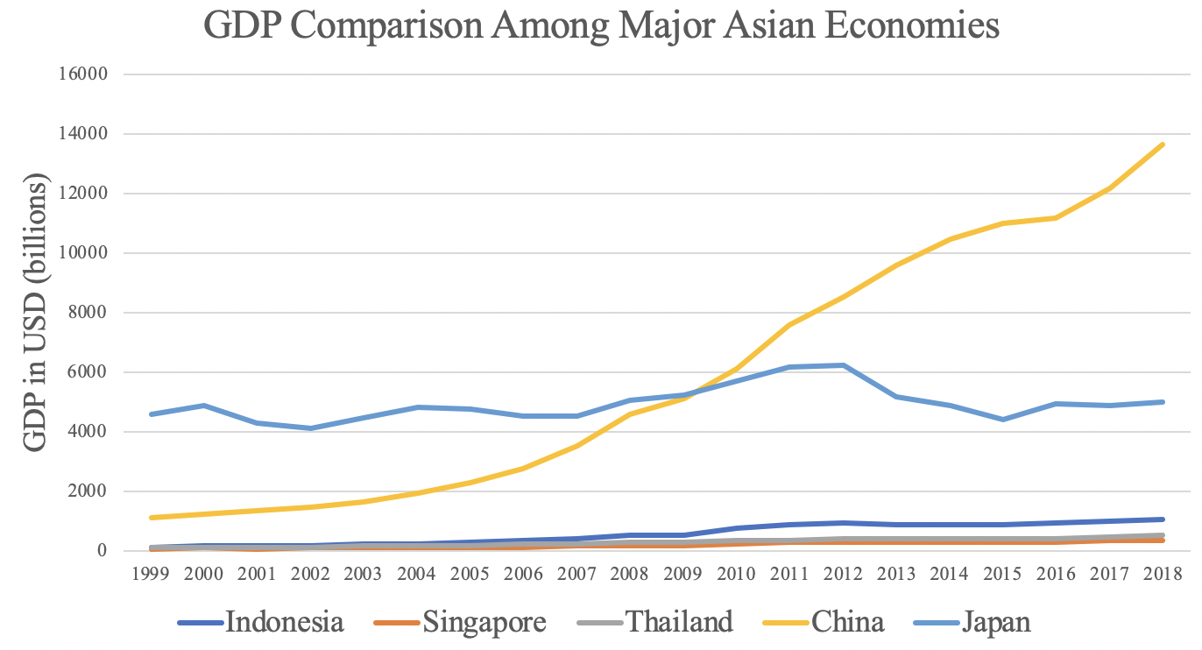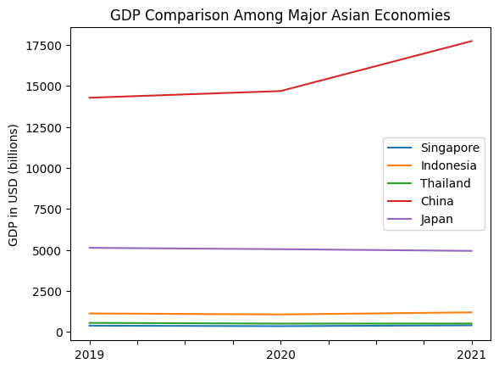

Figures 1a and 1b. GDP Comparison Among Peer Countries (left: 2013-2018; right: 2019-2021)

2.2 ECI Ranking and Changes
The Economic Complexity Index (ECI), as defined by Ricardo Hausmann and Cesar Hidalgo in 2009 to explain the knowledge accumulated in a country's population, is illustrated in Figures 2a and 2b.

As shown, Singapore exhibits a stably high production capability from 2013 to 2018, as measured by ECI. This is in direct contrast to the other Asian economies such as Indonesia, which demonstrates a huge disadvantage in both ECI growth rate and GDP growth rate.

The comparable countries maintain a small change in ECI level between 2019 and 2020, with a sharp change between 2020 and 2021. Singapore and peer countries such as Japan and China saw significant decline in ECI values. Singapore has seen a -247.91% increase in its ECI, which is less than Indonesia's (224.61%), China's (-195.21%), and Japan's (-197.52%).

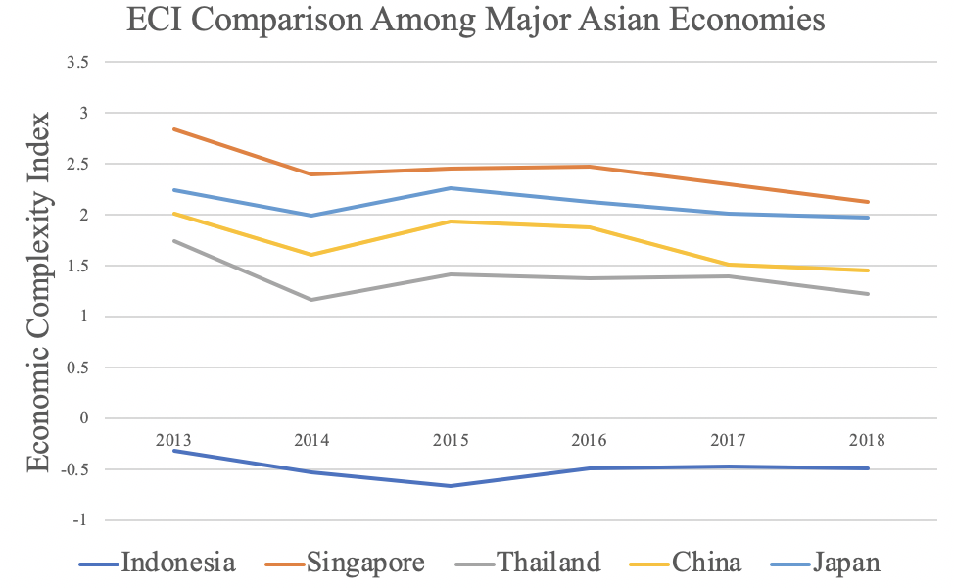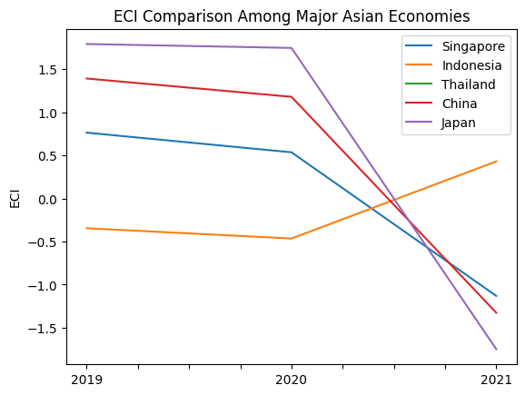

Figures 2a and 2b. ECI Comparison Among Peer Countries (left: 2013-2018; right: 2019-2021)

Figures 3a and 3b offer a further comparison of GDP Growth and ECI over the time span from 2013 to 2021 for Singapore. Similar to the GDP drop and further increase from 2013 to 2018, the GDP growth during the period from 2019 to 2021 is accompanied by a similarly volatile increase in ECI. The results show that the economic growth experienced by Singapore during the period from 2013 to 2018 is only partially consistent with the predictions by ECI and that Singapore made weak progress towards effectively developing a competitive product space that helps to accumulate complicated knowledge and technology. For the period 2019 to 2021, the ECI did not follow GDP trends. In order to provide a more concrete answer to why this has happened, we will dive into an analysis of Singapore’s production structure and its product space designs in the next few sections.

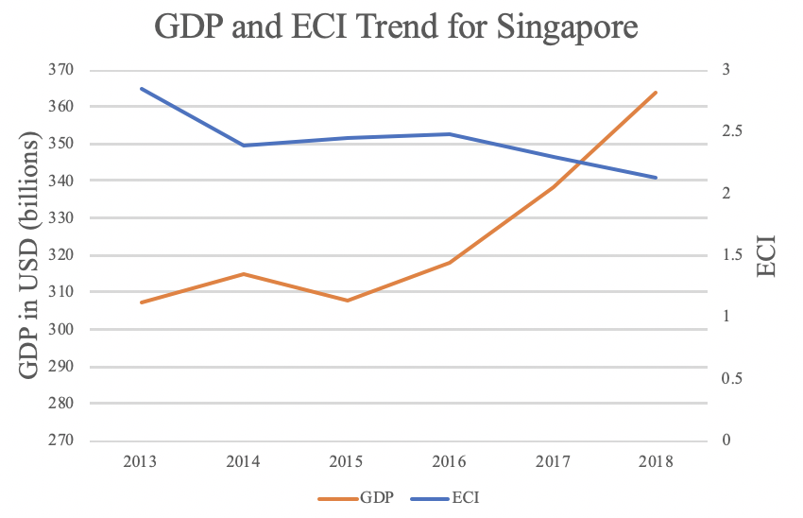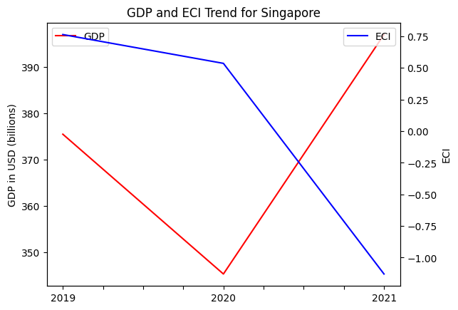

Figures 3a and 3b. GDP Growth and ECI for Singapore (left: 2013-2018; right: 2019-2021)

3. Production Analysis

3.1 Product Categorization
Our main data source in this research is the UN Comtrade Website (https://comtrade.un.org), which provides us with valuable information on countries’ export values on an annual basis, including highly specific export data for more than 5000 categories of products. In order to have a holistic vision of the product space of a country, however, a level of categorization is required. Products in our data source are labeled from 010000-999999, with the first two digits representing a general category to which the product belongs. Based on the 99 categories extracted from the label, we further group the products into the 18 most widely-accepted industries, as summarized in Table 1.

Note that the High-complexity Products industry group is not a distinct industry but rather an aggregated industry that encompasses the most complicated products from the most technologically-advanced industries (as measured by PCI). This industry serves as an indicator for us to quantitatively evaluate how well a country has performed in developing cutting-edge technologies and closing its technological gap with advanced economies, which has become a topic of wide concern today. Indeed, when we rank the 18 categories based on PfCI (an equivalent concept of PCI as calculated based on the 18 categorized product groups), the High-complexity Products industry has the highest PfCI among all industry groups.

Category | Description
Animals and By-products | All kinds of meat, livestock and related by-products
Vegetables, Fruits and Plants | All kinds of plants, edible vegetables and fruits
Food and Preparations | Edible preparations, raw cooking materials and appliances
Clothing and Accessories | All kinds of fabrics, filament, clothing and accessories
Textiles | All kinds of textile articles and related products
Wood Products | Book, paper and other elementary products related to wood
Metals | Mining of all sorts of raw Metals
Refined and Processed Stones | Refined or processed stone products such as pearl and ceramics
Energy Drilling and Mining | Mining industry for energy, minerals, stone materials, etc.
Daily Instruments | Basic daily instruments such as sport requisites, timing and measuring tools
Raw Manufacturing | Basic products made from plastic, rubber, leather, etc.
Chemical Manufacturing | Advanced chemical products and pharmaceutical products
Chemicals | Raw chemical materials and by-products
Machinery and Construction | Machinery and mechanical appliances, including electrical equipment
Transportation | Vehicles and locomotives including aircraft, ship, railway, etc.
Weapons | Explosives, arms and ammunition
Services and Utilities | Financial, business, legal, communication, travel Services and Utilities, etc.
High-complexity Products | Agglomeration of advanced products with highest PCIs
Table 1. Categorization of Products

We further observe a positive correlation between the GDP and the export of High-complexity Products. A higher adjusted R-square exists between GDP and High-complexity Products exports, indicating that more successful economics, as measured by GDP, tend to be those that are capable of producing and exporting High-complexity Products as we define them. Tables 2a and 2b show the OLS results in a universe of 107 and 21 typical countries respectively.

 | High-complexity Products | Food and Preparations | Animals and By-products
Adj. R-squared | 0.075 | 0.006 | 0.002
F-statistic | 9.556 | 1.638 | 1.175
No. Observations | 107 | 107 | 107
Table 2a. OLS Regression Results of GDP against Percentage Volume of Exports

 | High-complexity Products | Food and Preparations | Animals and By-products
Adj. R-squared | 0.149 | 0.003 | -0.012
F-statistic | 4.510 | 1.059 | 0.7542
No. Observations | 21 | 21 | 21
Table 2b. OLS Regression Results of GDP against Volume of Percentage Exports

3.2 Realized Industry Development
Based on the aforementioned product categorization, we aim to capture Singapore's realized industry production strategy between 2013 and 2021 on a complexity level. In Hausmann and Hidalgo (2009), distance is defined to be a measure of how far a country is from a certain product, not in its product space. We extend this concept to all product groups and quantify how technically equipped a country is to develop the corresponding product groups. In other words, the shorter the distance between a country and a product group, the more capable a country is of developing products within that group. Defining this net distance change as the Realized Industry Development (RID), our export data allow us to calculate and compare the RID of Singapore and the 18 product groups in 2021 and 2018 through the difference, where a positive RID indicates a shortening of the distance (i.e., advancement of the industry), and a negative RID indicates the reverse. It is notable that the number of industries with positive RID has decreased from two to one from 2018 to 2021.

Category | RID (2021) | RID (2018)
Daily Instruments | -0.037 | -0.064
Chemicals | -0.045 | -0.028
Weapons | 0.006 | -0.026
Wood Products | -0.041 | -0.020
Transportation | -0.000 | -0.107
Machinery and Construction | -0.009 | 0.018
Metals | -0.063 | -0.032
Raw Manufacturing | -0.015 | -0.022
Services and Utilities | -0.045 | -0.063
Clothing and Accessories | -0.058 | -0.008
Chemical Manufacturing | -0.013 | -0.016
Food and Preparations | -0.053 | -0.015
Textile | -0.015 | -0.022
High-complexity Products | -0.010 | -0.090
Vegetables, Fruits and Plants | -0.037 | -0.020
Animals and By-products | -0.046 | -0.017
Energy Drilling and Mining | 0.000 | 0.000
Precious Stones
Table 3. Realized Industry Development (RID) of Singapore
3.3 Regional and Global Comparison
Tables 4a-4b below summarize how the production strategy adopted by Singapore compares with selected leading economies in the world across different years, as measured in RID. Leading economies such as France, the United States, and Germany gave a considerable level of attention to more advanced product groups such as high-complexity products and food and preparations in 2018 and precious stones, energy drilling and mining, and services and utilities in 2021.

Ranking | France | The United States | Germany
1 | High-complexity Products | Services and Utilities | High-complexity Products
2 | Chemical Manufacturing | Weapons | Transportation
3 | Daily Instruments | Raw Manufacturing | Wood Products
4 | Animals and By-Products | Precious Stones | Metals
5 | Food and Preparations | Animals and By-products | Food and Preparations
Table 4a. RID Comparison across Leading Economies (2018)

Ranking | France | The United States | Germany
1 | Services and Utilities | Precious Stones | Daily Instruments
2 | Precious Stones | High-complexity Products | Transportation
3 | High-complexity Products | Services and Utilities | Chemicals
4 | Energy Drilling and Mining | Energy Drilling and Mining | Chemical Manufacturing
5 | Machinery and Construction | Wood Products | Clothing and Accessories
Table 4b. RID Comparison across Leading Economies (2021)

Tables 4c-4d further examine Singapore's development strategy against those of emerging economies on a global scale. Reasonably, emerging economies such as China, South Korea, and Singapore have devoted the majority of their efforts to intermediate industry groups, showing moderate shifts in strategies over the course of three years.

Ranking | China | South Korea | Singapore
1 | High-complexity Products | Transportation | Transportation
2 | Transportation | Textile | High-complexity Products
3 | Machinery and Construction | High-complexity Products | Precious Stones
4 | Energy Drilling and Mining | Chemical Manufacturing | Daily Instruments
5 | Daily Instruments | Machinery and Construction | Services and Utilities
Table 4c. RID Comparison across Emerging Economies (2018)

Ranking | China | South Korea | Singapore
1 | Chemicals | Chemicals | Weapons
2 | Daily Instruments | Daily Instruments | Energy Drilling and Mining
3 | Transportation | Transportation | Transportation
4 | Raw Manufacturing | Textile | Machinery and Construction
5 | Weapons | Raw Manufacturing | High-complexity Products
Table 4d. RID Comparison across Emerging Economies (2021)

4. Product Space Design

4.1 Suggested Development Vector
As outlined above, distance gives us an idea of how far each new product is from a country’s current mix of exports. As defined in Hausmann and Hidalgo (2009), distance is “the weighted proportion of products connected to goods p that country c is not exporting, i.e., MCP = 0.” Based on this definition, the distance between a country and any product that the country is currently exporting (i.e., the country is a significant exporter of the product as compared to the global average) is zero. Similarly, opportunity gain quantifies the contribution of a new product in terms of opening up the doors to more and more complex products. Intuitively, a product that a country is currently exporting (i.e., MCP = 1) has an opportunity gain of zero. An unreasonable investment in a certain product p would lead to a relative decrement in the export of more profitable products and therefore lead to a negative opportunity gain of product p. The opportunity gain is not the only estimator of a country’s level of economic development. However, among countries with comparable economic strength, those having higher ECI, or in other words, more reasonable economic structures are often in better shape.

Rank | Singapore | China | Germany
1 | Chemicals | Raw Manufacturing | Chemical Manufacturing
2 | Transportation | Clothing and Accessories | Wood Products
3 | High-complexity Products | Textile | Metals
4 | Services and Utilities | Machinery and Construction | Machinery and Construction
5 | Machinery and Construction | Transportation | Transportation
6 | Daily Instruments | Weapons | Weapons
7 | Weapons | Daily Instruments | High-complexity Products
8 | Textile | High-complexity Products | Services and Utilities
9 | Chemical Manufacturing | Precious Stones | Energy Drilling and Mining
10 | Raw Manufacturing | Services and Utilities | Precious Stones
11 | Clothing and Accessories | Chemicals | Textile
12 | Metals | Energy Drilling and Mining | Clothing and Accessories
13 | Wood Products | Chemical Manufacturing | Chemicals
14 | Precious Stones | Wood Products | Animals and By-products
15 | Animals and By-products | Animals and By-products | Vegetables, Fruits, and Plants
16 | Food and Preparations | Vegetables, Fruits, and Plants | Food and Preparations
17 | Energy Drilling and Mining | Metals | Daily Instruments
18 | Vegetables, Fruits, and Plants | Food and Preparations | Raw Manufacturing
ECI | 2.751108815 | 1.96086598 | 1.937171566
Table 5a. Opportunity Gain Ranking on a Comparable Scale (2013)

Rank | Singapore | China | Germany
1 | Energy Drilling and Mining | Chemicals | Chemical Manufacturing
2 | Chemicals | Raw Manufacturing | Machinery and Construction
3 | Machinery and Construction | Clothing and Accessories | Transportation
4 | Transportation | Textile | Daily Instruments
5 | High-complexity Products | Machinery and Construction | High-complexity Products
6 | Services and Utilities | Transportation | Services and Utilities
7 | Weapons | Weapons | Chemicals
8 | Textile | Daily Instruments | Textile
9 | Precious Stones | High-complexity Products | Weapons
10 | Chemical Manufacturing | Precious Stones | Clothing and Accessories
11 | Clothing and Accessories | Services and Utilities | Precious Stones
12 | Daily Instruments | Energy Drilling and Mining | Raw Manufacturing
13 | Animals and By-products | Wood Products | Wood Products
14 | Metals | Animals and By-products | Energy Drilling and Mining
15 | Raw Manufacturing | Metals | Animals and By-products
16 | Wood Products | Chemical Manufacturing | Metals
17 | Vegetables, Fruits, and Plants | Vegetables, Fruits, and Plants | Food and Preparations
18 | Food and Preparations | Food and Preparations | Vegetables, Fruits, and Plants
ECI | 2.112887919 | 1.700687855 | 2.959929484
Table 5b. Opportunity Gain Ranking on a Comparable Scale (2018)

Rank | Singapore | China | Germany
1 | Chemicals | Chemical Manufacturing | Chemical Manufacturing
2 | Machinery and Construction | Clothing and Accessories | Raw Manufacturing
3 | Transportation | Transportation | Wood Products
4 | Precious Stones | Weapons | Machinery and Construction
5 | Services and Utilities | Daily Instruments | Transportation
6 | Metals | Precious Stones | Weapons
7 | Chemical Manufacturing | Services and Utilities | Daily Instruments
8 | Clothing and Accessories | Energy Drilling and Mining | High-complexity Products
9 | High-complexity Products | High-complexity Products | Energy Drilling and Mining
10 | Raw Manufacturing | Textile | Precious Stones
11 | Wood Products | Metals | Clothing and Accessories
12 | Textile | Wood Products | Textile
13 | Animals and By-products | Chemicals | Food and Preparations
14 | Vegetables, Fruits and Plants | Animals and By-products | Vegetables, Fruits and Plants
15 | Daily Instruments | Vegetables, Fruits and Plants | Animals and By-products
16 | Food and Preparations | Raw Manufacturing | Services and Utilities
17 | Energy Drilling and Mining | Machinery and Construction | Chemicals
18 | Weapons | Food and Preparations | Metals
ECI | -1.129920784 | -1.861282363 | -1.325400334
Table 5c. Opportunity Gain Ranking on a Comparable Scale (2021)

We define the ranking of opportunity gain for a country c, as the Suggested Development Vector (SDV) of c. Tables 5a-5c summarize how the SDV of Singapore compares with a selected group of comparable and leading economies in the world, with the industry groups ranked in decreasing order of significance. We focus on SDV results for 2018 because they give the most accurate snapshot of complexity for global comparison in the absence of the irregular effects of the COVID-19 pandemic observed in 2021.

Light blue indicates zero opportunity gains and white indicates negative opportunity gains. There were no industries that have positive opportunity gain. In other words, those countries are already in the most stable and efficient economic structure. Without the necessity of economic transition, those countries merely need to maintain a steady and balanced economic development. In contrast, developing countries have nearly half of industries with positive opportunity gain. It can be concluded that Singapore shares the characteristics of developed countries, with a balanced economic structure that leans towards high-level industries.

Rank | The United States | South Korea | Japan | Indonesia
1 | Animals and By-products | Chemicals | Chemicals | Animals and By-products
2 | Vegetables, Fruits and Plants | Raw Manufacturing | Raw Manufacturing | Vegetables, Fruits and Plants
3 | Food and Preparations | Textile | Metals | Food and Preparations
4 | Energy Drilling and Mining | Metals | Transportation | Energy Drilling and Mining
5 | Chemicals | Transportation | Weapons | Chemicals
6 | Raw Manufacturing | Daily Instruments | Daily Instruments | Raw Manufacturing
7 | Wood Products | Services and Utilities | High-complexity Products | Wood Products
8 | Clothing and Accessories | Chemical Manufacturing | Services and Utilities | Clothing and Accessories
9 | Textile | Energy Drilling and Mining | Energy Drilling and Mining | Textile
10 | Metals | Clothing and Accessories | Clothing and Accessories | Metals
11 | Machinery and Construction | Precious Stones | Food and Preparations | Machinery and Construction
12 | Weapons | Wood Products | Precious Stones | Weapons
13 | Precious Stones | Food and Preparations | Chemical Manufacturing | Precious Stones
14 | Services and Utilities | High-complexity Products | Wood Products | Services and Utilities
15 | Transportation | Animals and By-products | Vegetables, Fruits and Plants | Chemical Manufacturing
16 | Chemical Manufacturing | Vegetables, Fruits and Plants | Animals and By-products | High-complexity Products
17 | Daily Instruments | Machinery and Construction | Textile | Transportation
18 | High-complexity Products | Weapons | Machinery and Construction | Daily Instruments
ECI | 0.6301643562 | 1.519092735 | 1.792342474 | -0.345375137
Table 6. SDV of Other Sample Countries (2019)

4.2 Budgeted Industry Development Strategy and Interpretation
The optimal budgeted industry development strategy aims to solve the most efficient allocations under the budgeted constraint of different situations of heuristic total export growth. In order to obtain such an allocation portfolio, we formulate an optimization problem as the following:



where k(x) is the second largest eigenvector of $M_{CC'}$ after adding $x$ to the original export vector, C is the country that we are interested in, P is the product space, B is the heuristic budget.

If we can solve this problem, then we can know what the largest ECI to which a country can improve. Accordingly, the optimal solution $x*$ that we obtain here is exactly our optimal allocation. However, the biggest problem is that the objective function is not convex. Therefore, we cannot apply the classical tools for convex optimization to this problem. In order to solve this problem, our idea is to use a greedy algorithm. The way that we apply the greedy algorithm is that firstly we separate the total budget into k equal parts, and then for the first equal part we try to search for the product that can optimize our objective function by iterating through each $p∈P$. After we find the optimal product p for this equal part, we add the amount back to the export value of this product p and update the ECI for this country. If we observe that ECI does not change after iterating all the products, then we can add up one more equal part to invest. Until we find there is an ECI increment, we add the amount now to that product. The equal rest parts can be done in the same way.

By definition, a greedy algorithm is a kind of local search algorithm that is possible to run into a local minimum. Therefore, for local search algorithms, one typical way to keep it away from the local minimum is to enhance the vision of the algorithm by looking more steps forward. In our setting, whenever we obtain an increment of ECI, we mark down the required amount of export growth. Simultaneously, we continue searching for the next ECI increment point, compare the ratios of these two possibilities and pick the largest one. The ratio is defined as the following:

where ${ECI}_{p}$ is just the ECI of the country after adding some amount of export increment to product $p$, which is exactly the amount that is able to make ECI change. Also, we can express it in the way of $||$$x_{p}-x_{0}$${||}_{1}$.

In this way, we can obtain a further sighted greedy algorithm. Also, the number of parts that we would like to separate the budget into also matters. In order to solve this problem, we added a stabilizer on top of the enhanced greedy algorithm by running the algorithm for different numbers of parts and selecting the portfolio with the largest ECI increment and most complex economic structure.

Besides, it is quite common that there is a surplus in the budget. To deal with the surplus, we just add it to the product which needs the least amount of dollars to make $M_{cp}$ = 1 (i.e., the smallest amount of required export increase).

Economic Panel
As stated above, the enhanced greedy algorithm is developed mainly for solving the optimal allocation strategy. In order to visualize this allocation, an economic panel is created, consisting of a pie chart, a line chart and a table. First, a pie chart is used to show the percentage of each product in the optimal portfolio. The number located in the center of the circle denotes the heuristic growth of total export, which is also our budget. Each category in the chart has a determined percentage of the allocated budget. The lines below the pie charts show how the ECI changes during the searching process of the greedy algorithm. Even though sometimes an increase of the export by 15% or 20% does not seem reasonable to developed countries, yet it can also give a sense of how a country should develop in the long term. Eventually, the graph in the end is just for numerical explanation for the pie charts.

Interpretation
For the purpose of a clear explanation of the line charts, we label all the products in Table 7. Please refer to this table when trying to understand the investment trajectories in the line charts.

Label | Product Names
1 | Animal and By-products
2 | Vegetables, Fruits and Plants
3 | Food and Preparations
4 | Energy Drilling and Mining
5 | Chemicals
6 | Chemical Manufacturing
7 | Raw Manufacturing
8 | Wood Products
9 | Clothing and Accessories
10 | Textile
11 | Metals
12 | Machinery and Construction
13 | Transportation
14 | Weapons
15 | Daily Instruments
16 | Precious Stones
17 | High-complexity Products
18 | Services and Utilities
Table 7. Products Labeling

Figures 4a-4c show an economic panel for Singapore in 2013, 2018, and 2021. We can see that for different percentages of heuristic total export growth, the ECIs of Singapore actually have different increments.

For 2013, we can see that for different percentages of heuristic total export growth, the ECI of Poland has relatively similar performance. From all the four line graphs, we see that Singapore obtains some great increment in terms of ECI. However, increasing the budget for too large an amount would not produce a higher and higher ECI. Also the optimal ECI that we can achieve is the same for each case. This means that in longer terms, Singapore does not have a lot of room to improve. For the four export growth budget, the increment of ECI depends on chemicals, machinery and construction. A more detailed numerical representation of the portfolio is shown in Table 8a.
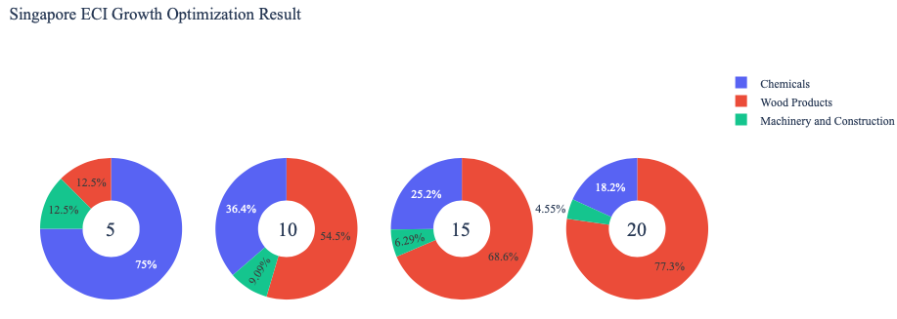
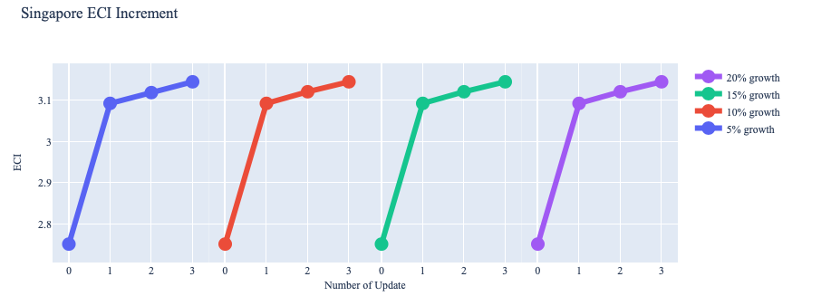

Figure 4a. Greedy-Based ECI Improvement Results of Singapore with Different Budgets (2013)

Singapore (2013)
Original ECI | 2.751
Heuristic Export Growth | 5% | 10% | 15% | 20%
Heuristic Export Growth (US. $) | 3.22E+10 | 6.44E+10 | 9.66E+10 | 1.29E+11
Machinery and Construction (US. $) | 4.02E+09 | 5.85E+09 | 5.85E+10 | 5.85E+09
Wood Products (US. $) | 4.02E+09 | 3.51E+10 | 6.38E+10 | 9.95E+10
Chemicals (US. $) | 2.41E+10 | 2.34E+10 | 2.34E+10 | 2.34E+10
Increased ECI | 3.144 | 3.144 | 3.144 | 3.144
Table 8a. Portfolio of Singapore (2013)

For further suggestions on Singapore’s development in the future, we also offer the optimization result of Singapore based on export data in 2018. Below is the economic panel for Singapore in 2018. We can see that for different percentages of heuristic total export growth, the ECI growth pattern of Singapore is similar to the one in 2013. From all the four line graphs, it still reaches the same optimal ECI eventually. This means that Singapore does not have a lot of room to improve, especially for the case of 5% growth, where the increment of ECI can barely be observed. However, our optimization method shows Singapore still can have gains by investing in machinery and construction, services industry and high complexity products. Therefore, for future strategy, Singapore should prioritize development of these three products in order to optimize the ECI.
A more detailed numerical representation of the portfolio is shown in Table 8b.

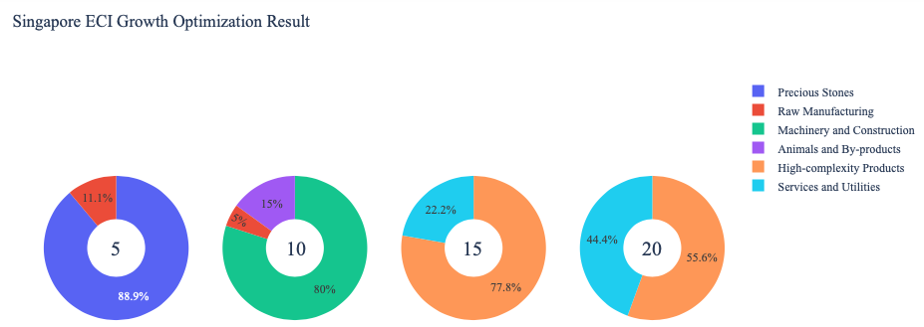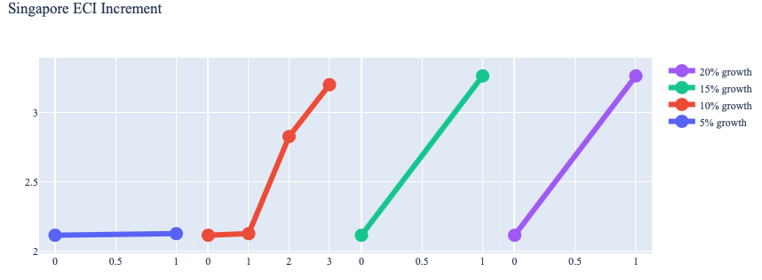
Figure 4b. Greedy-Based ECI Improvement Results of Singapore with Different Budgets (2018)

Singapore (2018)
Original ECI | 2.11
Heuristic Export Growth | 5% | 10% | 15% | 20%
Heuristic Export Growth (US. $) | 3.22E+10 | 6.44E+10 | 9.65E+00 | 1.29E+11
Animals and By-products (US. $) | 0.00E+00 | 9.65E+09 | 0.00E+00 | 0.00E+00
Raw Manufacturing (US. $) | 3.58E+09 | 3.22E+09 | 0.00E+00 | 0.00E+00
Machinery and Construction (US. $) | 0.00E+00 | 5.15E+10 | 0.00E+00 | 0.00E+00
Precious Stones (US. $) | 2.86E+10 | 0.00E+00 | 0.00E+00 | 0.00E+00
High-complexity Products (US. $) | 0.00E+00 | 0.00E+00 | 7.51E+10 | 7.15E+10
Services and Utilities (US. $) | 0.00E+00 | 0.00E+00 | 2.15E+10 | 5.72E+10
Increased ECI | 2.12 | 3.20 | 3.27 | 3.27
Table 8b. Portfolio of Singapore (2018)

To compare with the performance in 2013 and 2018, we also re-examine suggested strategies for 2021. For 2021, a 5 percent increase in export would emphasize High-complexity Products, followed by Energy Drilling and Mining for 10 and 20 percent export growth and Precious Stones for 15 percent export growth. These strategies go in line with the suggested trajectories based on ECI. Our line graph in figure 4c shows the most growth potential in investing in Precious Stones followed by Energy and Drilling. Increased investment in High-complexity Products will produce a positive output, but not as great compared to the other two categories. A more detailed numerical representation of the portfolio for Singapore is shown in Table 8c.
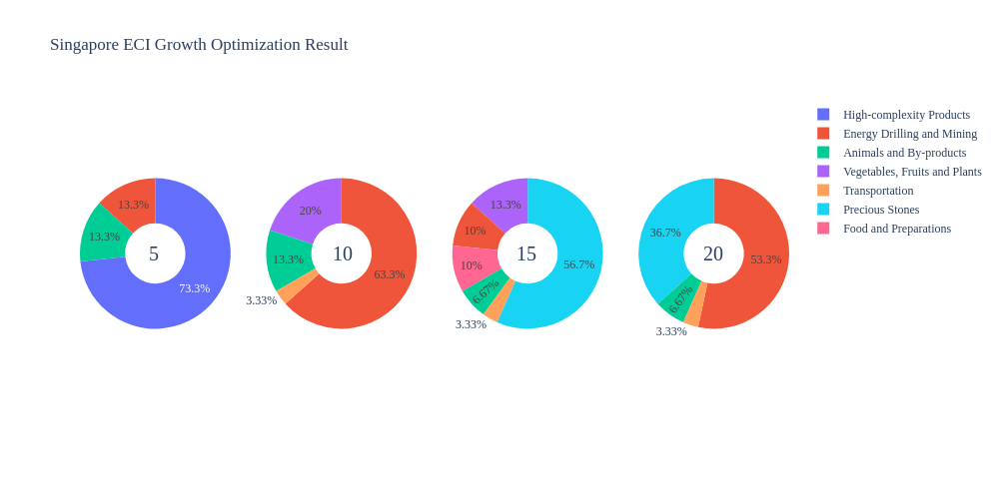
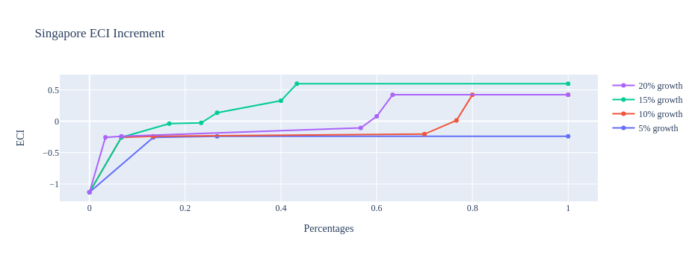
Figure 4c. Greedy-Based ECI Improvement Results of Singapore with Different Budgets (2021)

Singapore (2021)
Original ECI | -1.130
Heuristic Export Growth | 5% | 10% | 15% | 20%
Energy Drilling and Mining | 3.44E+09 | 3.44E+09 | 5.17E+09 | 5.86E+10
Animals and By-products | 6.90E+09 | 6.90E+09 | 1.81E+10 | 6.20E+10
High-complexity Products | 2.59E+10 | 0.00E+00 | 0.00E+00 | 0.00E+00
Transportation | 0.00E+00 | 4.13E+10 | 3.36E+10 | 6.55E+10
Vegetables, Fruits and Plants | 0.00E+00 | 5.17E+10 | 3.10E+10 | 0.00E+00
Increased ECI | 0.891 | 1.551 | 1.728 | 1.552
Table 8c. Portfolio of Singapore (2021)

4.3 Sensitivity Analysis and Contingency Strategy
In the following section, our broad aim is to understand how sensitive Singapore is to changes in export in various industries. While the Economic Complexity Index has been shown to contain valuable information about the economic strength/capacity of a country, little has been said as to the stability of the measure itself. We seek to uncover the main drivers of stability under a country's ECI score and better understand longer-term projections for ECI growth. Additionally, gaining an intuition on the industries that are bolstering an economy and the industries that offer the greatest return per unit of investment is best done through visualization of industry-specific sensitivity. To this end, we have developed two categories of sensitivity analysis.
ECI Sensitivity Graph
First, in order to assess the effect particular industries have on each respective country, we developed ECI Sensitivity graphs (Figure 5). We use the shocking methodology to increment or decrement an industry’s export level by a certain percentage and recalculate the ECI, all else being equal. While freezing the export dynamics of the rest of the world and enacting an instantaneous shock in export for a particular industry and country may not reflect real-life dynamics, what it does offer us is an understanding of a country’s level of dependency on an industry in the context of ECI. The shocking is done in small percentage increments in order to smooth out the resulting curve. Additionally, a recurring theme one will see is that for most industries, a breaking point occurs where the ECI either jumps upwards or downwards, creating a hockey stick shape rather than a linear trend. While the inflection point may not be accurate in the context of real life, comparing the various inflection points across industries can give us valuable insight.

Figure 5. Sample ECI Sensitivity Graph (2018)
The graphs are formulated as follows. There are six ECI Sensitivity graphs, two for each of the following years: 2021, 2018, and 2013. The first chart, Incremental ECI Sensitivity, shows positive shocking in which export numbers are shocked upwards per industry. The X-axis is in terms of percentage shock per current dollar value of export. The Y-axis is the recalculated ECI level post-shocking. The second chart, Decremental ECI Sensitivity, follows the same format except the X-axis represents negative shock. In other words, exports for each industry are decremented, and the ECI is accordingly recomputed.
SDV Sensitivity
Secondly, we analyze the sensitivity of the SDV to changes in export levels. The goal is to understand how export level changes for a particular industry can affect the marginal opportunity gain for other industries. We will be using specifically high-complexity products and food and preparations as our base industries. We will be increasing or decreasing the absolute export level in both of these industries and observing the effects on the SDV.
When the opportunity gain of an industry is negative, the SDV sensitivity approximates how an over-development of the industry jeopardizes the economic structure of a country. When the opportunity gain of the industry is zero, the SDV sensitivity determines whether the further development of the industry shapes the country with a better economic structure and predicts how the SDV would change accordingly. Specifically, as we reduce the export of such an industry to 25% - 50% of its original value, a few other industries originally with negative opportunity gain could likely become profitable.
Similar to the ECI sensitivity graphs above, we will be shocking the export of high-complexity products and food and preparations in small percentage increments. A new SDV, represented by a new column in the charts, is recorded only when a certain level of shock changes the structure of the SDV. In effect, we are incrementing or decrementing export levels of two industries until the marginal opportunity gain of any industry changes in category (positive, negative, or neutral). Below is an example of an SDV Sensitivity chart with Positive Shocking. Industries with positive marginal opportunity gain are colored blue, neutral is colored white, and negative is colored red.


Table 9. Sample Incremental SDV Sensitivity for High-Complexity Products (2018)
Contingency Plan
The Contingency Plan aims to present a set of solutions with respect to upheavals in different industries. Instead of compensating for the declining production directly, the best strategy is to develop those incipiently profitable industries. In this manner, we can derive a contingency strategy for countries to deal with possible abrupt declines of crucial industries. In some cases, the SDV remains unchanged even when a zero-opportunity-gain industry declines to 20% in terms of export. We can then conclude the industry is not indispensable to the country. As a clarification, the three consecutive N/As mean that the country doesn’t even need to respond to a collapse in the industry. Countries tend to have distinct solutions to the ups and downs of the same industry. To create the contingency strategy table, we decrease the export level for each industry in the country’s current production space by 60% respectively. The three highest-ranking industries in the new SDV are then returned.

Product Names | 0 | 1 | 2
Animal and By-products | Services and Utilities | Daily Instruments | Weapons
Vegetables, Fruits and Plants | Services and Utilities | Daily Instruments | Weapons
Food and Preparations | Services and Utilities | Daily Instruments | Weapons
Energy Drilling and Mining | Services and Utilities | Daily Instruments | Weapons
Chemicals | Services and Utilities | Daily Instruments | Weapons
Chemical Manufacturing | Services and Utilities | Daily Instruments | Weapons
Raw Manufacturing | Services and Utilities | Daily Instruments | Weapons
Wood Products | Services and Utilities | Daily Instruments | Weapons
Clothing and Accessories | Services and Utilities | Daily Instruments | Weapons
Textile | Services and Utilities | Daily Instruments | Weapons
Metals | Services and Utilities | Daily Instruments | Weapons
Machinery and Constructions | Services and Utilities | Daily Instruments | Weapons
Transportation | Services and Utilities | Raw Manufacturing | Daily Instruments
Weapons | Services and Utilities | Daily Instruments | Transportation
Daily Instruments | Services and Utilities | Weapons | Transportation
Precious Stones | Services and Utilities | Daily Instruments | Weapons
Daily Instruments | Services and Utilities | Daily Instruments | Weapons
Services and Utilities | Daily Instruments | Weapons | Transportation
Table 10. Sample Contingency Strategy (2019)

4.3 Sensitivity Analysis Results and Interpretation

We examine Singapore's ECI Decremental and Incremental Sensitivity Charts for 2021. An increase in Food and Preparation will lead to the highest change in ECI, followed by High-complexity Products. The strong sensitivity effect of manipulating the high-complexity products and Transportation categories remains consistent with previous years. For the negative shock cases, chemical manufacturing becomes most impactful. The rest of the industries do not appear to have the same level of sensitivity.

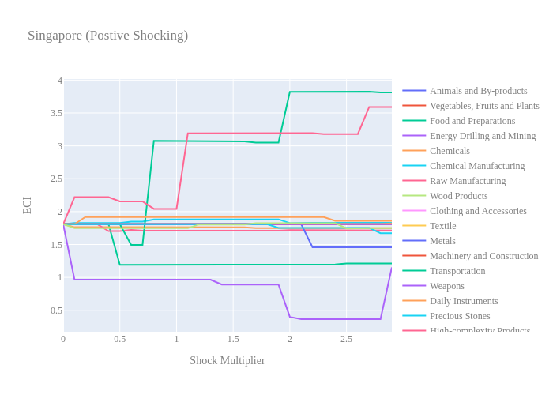
Figure 6a. Incremental ECI Sensitivity for Singapore (2021)
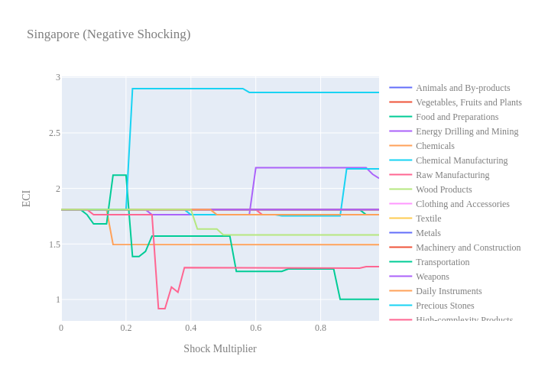
Figure 6b. Decremental ECI Sensitivity for Singapore (2021)

Below, we consider Singapore’s 2018 Negative Shock chart. We can see that Singapore is highly sensitive to High Complexity Products, Transportation and Machinery. This is expected from a well-diversified, developed country. Additionally, decreases in export of Energy & Drilling, Services and Utilities and Chemicals seem to increase the overall ECI score.
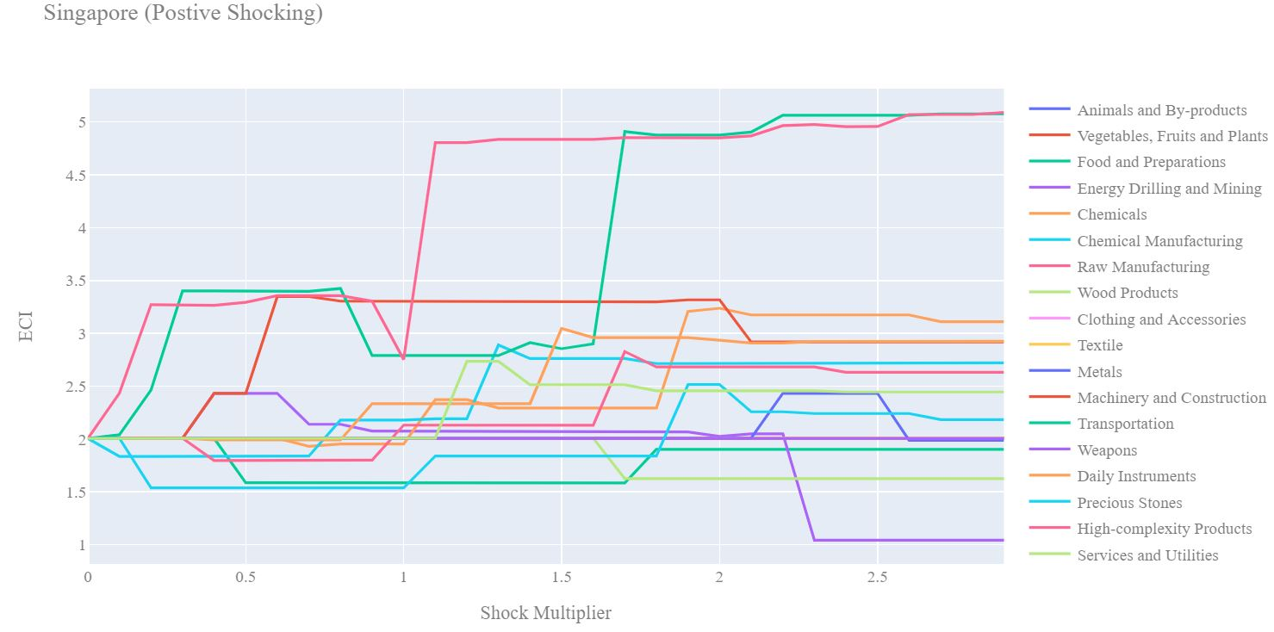
Figure 7a. Incremental ECI Sensitivity for Singapore (2018)

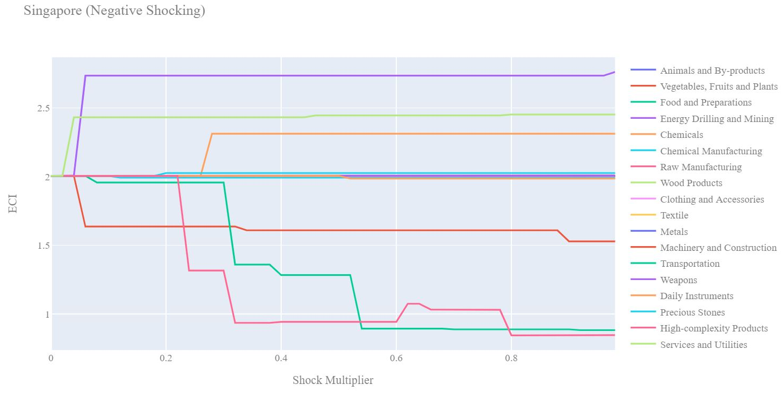
Figure 7b. Decremental ECI Sensitivity for Singapore (2018)

Next we consider the 2013 ECI Sensitivity graphs. We see that in the positive shocking case most industries giver either no benefit or cause drawdowns in the ECI. However increased export of High Complexity Products can lead to higher ECI but over 250% increase in export is required.

In the 2013 negative shocking case, we see that again Singapore is marginally less sensitive to downturns than in the 2018 sensitivity profile. This suggests that Singapore has become more sensitive to export downturns in High Complexity Products and Transportation in the recent past as their economy begins to rely more heavily on these industries to bolster their ECI score.
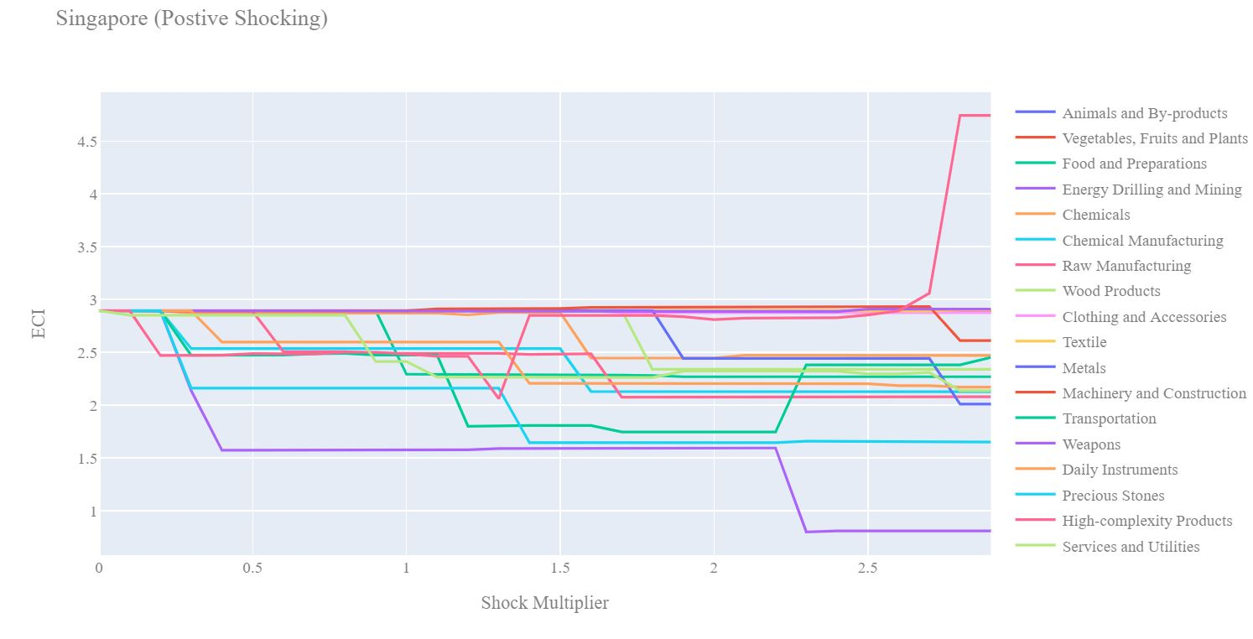
Figure 8a. Incremental ECI Sensitivity for Singapore (2013)

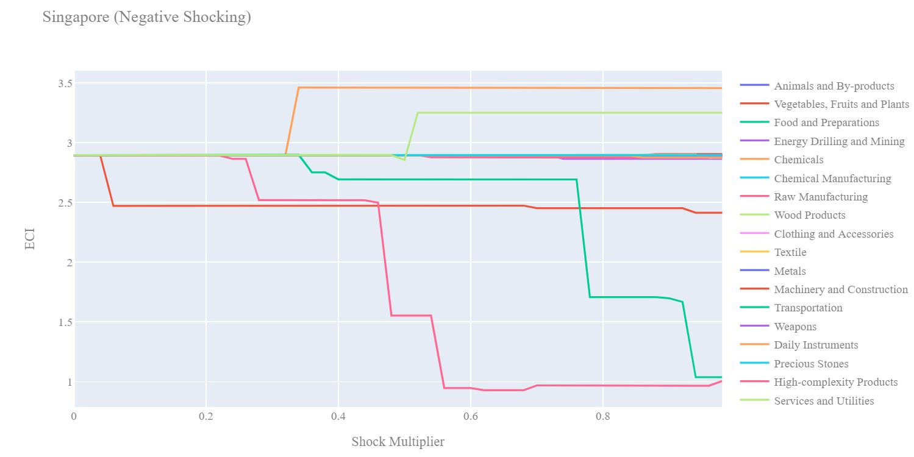
Figure 8b. Decremental ECI Sensitivity for Singapore (2013)

Below we see the SDV sensitivity charts for High Complexity Products (Table 11). We see that fairly small decreases in export of High Complexity Products makes room for other industries to shift from the negative opportunity gain to neutral opportunity gain territory. No industries become immediately attractive after a drawdown of High Complexity Products.

Considering the positive SDV sensitivity chart we observe that as exports of High Complexity products increases industries that were not worth investing begin to shift to the positive opportunity gain region. Intuitively as High Complexity Products become a stronger industry for Singapore, other industries start to become viable industries to pursue.

Rank | Incremental | Decremental
1 | Machinery and Construction | Vegetables, Fruits and Plants
2 | Chemicals | Services and Utilities
3 | Daily Instruments | Energy Drilling and Mining
4 | Services and Utilities | Precious Stones
5 | Textile | Daily Instruments
6 | Transportation | Transportation
7 | Chemical Manufacturing | Machinery and Construction
8 | Weapons | Food and Preparations
9 | High-complexity Products | Raw Manufacturing
10 | Clothing and Accessories | Chemical Manufacturing
11 | Raw Manufacturing | Chemicals
12 | Precious Stones | High-complexity Products
13 | Wood Products | Textile
14 | Metals | Weapons
15 | Energy Drilling and Mining | Clothing and Accessories
16 | Animals and By-products | Metals
17 | Food and Preparations | Wood Products
18 | Vegetables, Fruits and Plants | Animals and By-products
ECI | 4.804992937 | 0.843364788
Table 11. Singapore’s SDV Sensitivities for High-complexity Products (2018)

Below we see the SDV sensitivity charts for Food and Preparations. As expected for a developed country, Singapore is not very sensitive in both the positive shocking and negative shocking case to Food and Preparations. The country's SDV is largely unaffected by this particular industry.

Rank | Incremental | Decremental
1 | Vegetables, Fruits, and Plants | Vegetables, Fruits, and Plants
2 | Services and Utilities | Transportation
3 | Transportation | Machinery and Construction
4 | Machinery and Construction | Food and Preparations
5 | Energy Drilling and Mining | High-complexity Products
6 | High-complexity Products | Energy Drilling and Mining
7 | Chemicals | Chemicals
8 | Textile | Services and Utilities
9 | Daily Instruments | Daily Instruments
10 | Chemical Manufacturing | Textile
11 | Weapons | Chemical Manufacturing
12 | Clothing and Accessories | Weapons
13 | Raw Manufacturing | Clothing and Accessories
14 | Precious Stones | Precious Stones
15 | Wood Products | Raw Manufacturing
16 | Metals | Wood Products
17 | Animals and By-products | Metals
18 | Food and Preparations | Animals and By-products
ECI | 2.005369933 | 1.90194945
Table 12. Singapore’s SDV Sensitivities for Food and Preparations (2018)

4.4 Contingency Strategy
Decreasing export of each industry in [Country]’s current production space by 60% respectively, we derive the contingency strategy shown below.

Product Names | 0 | 1 | 2
Animal and By-products | Machinery and Construction | Chemical Manufacturing | Services and Utilities
Vegetables, Fruits and Plants | Machinery and Construction | Chemical Manufacturing | Services and Utilities
Food and Preparations | Machinery and Construction | Chemical Manufacturing | Services and Utilities
Energy Drilling and Mining | Services and Utilities | High-complexity Products | Precious Stones
Chemicals | Chemicals | Chemical Manufacturing | Machinery and Construction
Chemical Manufacturing | Machinery and Construction | Chemical Manufacturing | Services and Utilities
Raw Manufacturing | Machinery and Construction | Chemical Manufacturing | Services and Utilities
Wood Products | Machinery and Construction | Chemical Manufacturing | Services and Utilities
Clothing and Accessories | Machinery and Construction | Chemical Manufacturing | Services and Utilities
Textile | Machinery and Construction | Chemical Manufacturing | Services and Utilities
Metals | Machinery and Construction | Chemical Manufacturing | Services and Utilities
Machinery and Construction | Machinery and Construction | Chemical Manufacturing | Services and Utilities
Transportation | Services and Utilities | Daily Instruments | High-complexity Products
Weapons | Machinery and Construction | Chemical Manufacturing | Services and Utilities
Daily Instruments | Machinery and Construction | Chemical Manufacturing | Services and Utilities
Precious Stones | Machinery and Construction | Chemical Manufacturing | Services and Utilities
High-complexity Products | Services and Utilities | Transportation | Precious Stones
Services and Utilities | High-complexity Products | Services and Utilities | Machinery and Construction
Table 13. Singapore’s Contingency Strategy (2018)

5. Macro-level Predictions

5.1 Structural Optimality Index
ECI sensitivity described in the section before has proven to be a significant factor in deciding the economic outcomes of countries. In order to quantitatively evaluate how effective our development strategies are and how deviations from the suggested developmental path will lead to suboptimal growth results, we define the measure – Structural Optimality Index (SOI) – on a country level as the Adjusted R-Square obtained from regressing the country’s realized industry development over the suggested development strategy. Both strategies are quantified in nature, with the realized development represented by increasing export in every major industry group and the suggested development strategy represented by the opportunity gains of developing the corresponding industry groups as calculated in previous sections. The adjusted R-square from the regression thus provides us with a quantified measure of how the development path adopted by the country has fitted with/differed from calculations on a complexity level.

After obtaining this measure for all countries in our database, we further regress countries’ five-year economic growth, which is defined as the percent increase in GDP (USD), over their SOI. Figure 9 illustrates the regression output, which shows a strong positive correlation between countries’ SOI and their five-year GDP growth, significant at the 1% level and achieving an adjusted R² of 0.045%. In other words, the more a country develops as suggested by calculations on a complexity level, the better economic outcomes it achieves.

Table 14: OLS Regression Results
Dep. Variable: GDP | F-Statistic: 5.963
R²: 0.054 | Prob (F-Stat): 0.0163
Adj R²: 0.045 | No. Observations: 106


Figure 9. Regression of Five-Year GDP Growth over SOI (2013-2018)

5.2 SOI of Singapore and Its Implications
Singapore, for instance, has a relatively low level of structural optimality as compared with its peers. As the regression in Figure 7 suggests (the orange curve represents export increase and the blue curve stands for opportunity gain of the corresponding industry), Singapore demonstrates a low level of correlation with the suggested developmental path, having an adjusted R-square of around -5.1% and a 5-year growth rate of 28.2%. Here the SOI underestimates the expected growth of the country. This is in direct contrast to emerging economies such as Turkey, where there is a high SOI of around 21.8% and a corresponding 5-year GDP growth of 36.7%, making it one of the fastest developing economies during the period. In sum, Singapore’s stagnant economic progress from 2013 to 2018 can be at least partially explained by a mismatched development strategy that demonstrates a considerable level of deviations from our suggested developmental path. In specific, Singapore invested heavily in the Transportation industry, while it should have focused more on industry groups such as Machinery and Construction.

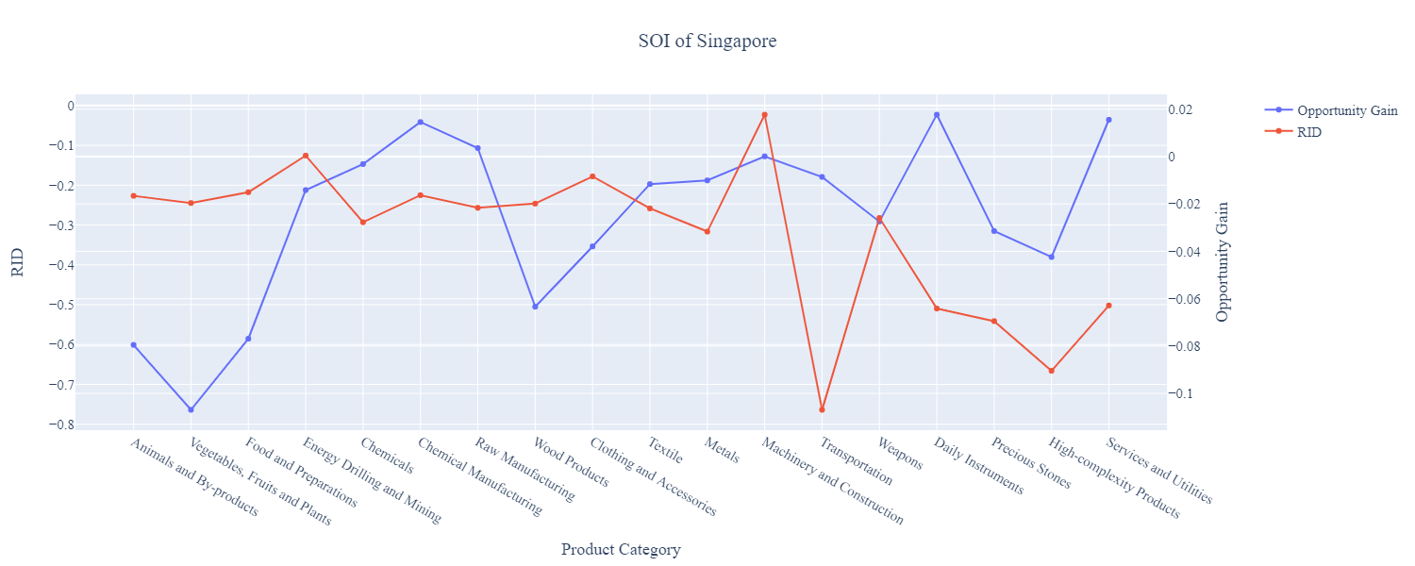
Figure 10a. SOI of Singapore (2013-2018)

For the 2019-2021 years, Singapore has a strong presence in the Weapons and Energy Drilling and Mining industries. The weapons industry seems to be overdeveloped when considering their lower opportunity gain relative to RID but Energy Drilling and Mining still presents a good opportunity for further investment. It also could consider investing in Precious Stones and Chemical Manufacturing to improve its growth. Singapore has seen a growth in GDP over those three years of 5.87%, with an average growth of 2.31%, compared to 3.6% for the average yearly growth for the five years prior.

Higher than before, its adjusted R-squared value of 0.391 now indicates a high correlation between the GDP growth and the implemented development path. Progress is slow on a global scale during this period, but Singapore demonstrates a greater ability to adjust to negative economic shocks by improving SOI and increasing GDP growth than it did between 2013 and 2018.

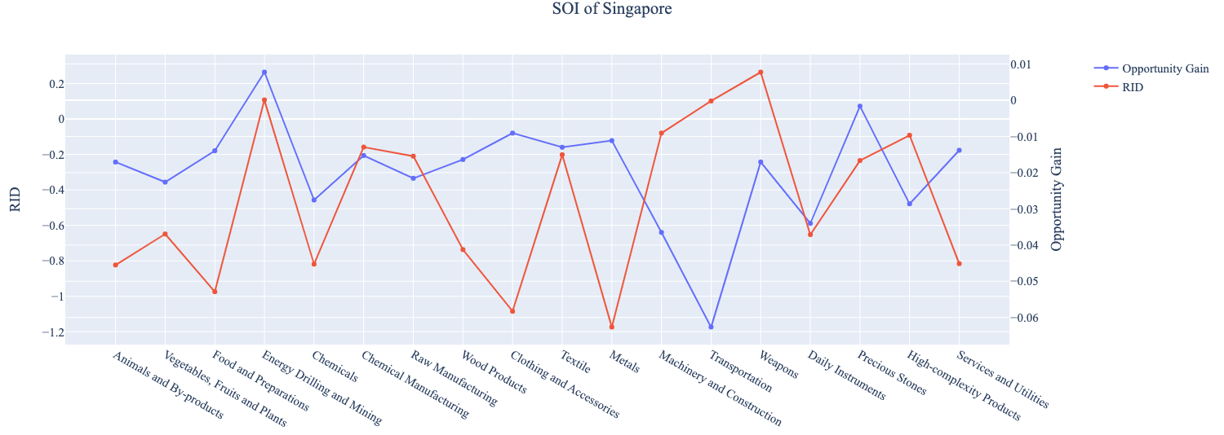
Figure 10b. SOI of Singapore (2019-2021)

6. Concluding Remarks

In conclusion, Singapore has demonstrated a low level of economic growth in terms of GDP during the period from 2013 to 2018, concurrent with a stagnation in economic complexity as compared with other major Asian economies.

The level of economic progress during the period, we believe, can be partially explained through analysis of the economic and product complexity structure of Singapore on the industry group level. The product classification system we adopt allows us to measure the realized industry development for various industry groups and to observe that Singapore invested heavily in developing Transportation, High-complexity Products during the period.

Based on our analysis of the opportunity gain and a sensitivity analysis of major industry groups, Singapore can further its gains by prioritizing Chemicals, Machinery and Construction. We further note that Singapore has a slightly mismatched development strategy that indicates a moderate level of structural optimality on the complexity level, having an adjusted R-square of around -5.1%. Since a significant positive correlation exists between five-year GDP growth and the structural optimality index of an economy as we define and calculate, Singapore indeed has a suboptimal growth experience as compared with fast-growing economies both on a regional scale and on a global scale, and has the potential to further its economic gains through industrial structure optimization as suggested in the paper.

During the second examined period from 2019 to 2021, Singapore performed much weaker than before and compared to other countries, such as Indonesia and China. We infer that during the COVID-19 period, Singapore focused on developing Weapons and Energy Drilling and Mining industries despite a lower demand for these industries given the global economic downturn. We also note that Singapore has increased its investment in the sectors identified earlier, leading to a strong boost from Machinery and Construction industries, leaving some room for strategic improvement. The ECI suggests that greater growth could have been achieved through Precious Stones followed by High Complexity Products and Energy Drilling and Mining. The surprising growth also increased the adjusted R-squared value to 39.1% in 2021 from -5.1% in 2018, demonstrating the pursued strategies contributed to the GDP. With the revised focus, Singapore has further potential to advance its economic growth to maintain its position among other countries to continue its post-pandemic recovery.

References

Hausmann, R., Hidalgo, C., Bustos, S., Coscia, M., Chung, S., Jimenez, J., Simoes, A. and Yıldırım, M. (2007). The Atlas of Economic Complexity. [online] Atlas.cid.harvard.edu. Available at: http://atlas.cid.harvard.edu/.

Balassa, B., “The Purchasing Power Parity Doctrine - A Reapprais- al,” Journal of Political Economy 72, 584-596 (1964).

Feenstra, R.; Lipsey, R.; Deng, H.; Ma, A. & Mo, H. “World Trade Flows: 1962-2000” NBER working paper 11040. National Bureau of Economic Research, Cambridge MA (2005).

United Nations Commodity Trade Statistics Database (http://comtrade.un.org/db/), accessed in August 2019.

The World Economic Forum, “The global competitiveness report,” (various years).

Barro, R. & Lee, J-W. “A New Data Set of Educational Attainment in the World, 1950-2010,” NBER Working Paper No. 1590 (2010).

Kaufmann, D. & Kraay, A. “Governance Indicators: Where Are We, Where Should We Be Going?” Policy Research Working Paper 4370. Washington, DC: World Bank (2008).

Hanushek, E.A. & Woessmann, L. “The Role of Cognitive Skills in Economic Development,” Journal of Economic Literature 46(3), 607- 668 (2008).

